**CHR Web Application Guide, v1.0**

**Author: Randall Stapleton (stapletonrc@etsu.edu), April 2023**

**Editor: Phil Pfeiffer (phil@etsu.edu)**

Table of Contents

1 Introduction 2

1.1 About This Document 2

1.2 Prerequisites 2

2 Installing CHR-Plot and CHR-DataGrab 3

2.1 Step 1: Move the Applications’ Files to the Remote Server 3

2.1.1 Access the Remote Server 3

2.1.2 Copy the Applications Files to the Remote Server 3

2.2 Step 2: Enable Internet Information Services 4

2.3 Step 3: Set Up IIS and File Directories 5

2.3.1 Create a Directory and Move Files into it 5

2.3.2 Create a Website in IIS 5

2.4 Step 4: Set Permissions 7

2.5 Step 5: Install the Net 6.0 Framework 9

2.6 Step 6: Test the Application 10

2.6.1 Verify that the Application was Installed 10

2.6.2 Identify the Application’s URL 11

2.6.3 Access the URL 11

2.7 Step 7: Opening and Closing Ports 12

2.7.1 Opening Ports 12

2.7.2 Closing Ports 14

2.8 Troubleshooting 17

2.8.1 Permissions 17

2.8.2 Application Pool 17

3 Using CHR-Plot 19

4 Using CHR-DataGrab 23

5 Installing and Using CHR_DataMove 25

5.1 Installing CHR_DataMove 25

5.1.1 Updating Defaults 25

5.1.2 Setting Privilege Levels 25

5.2 Using CHR_DataMove 26

6 CHR Web Application – What Was Not Finished 28

# Introduction

## About This Document

This guide outlines a procedure for installing the CHR Web Application and its supporting utilities. The main application, CHR-Plot, was created by ETSU M.S. students between 2021 and 2023[1] at the request of Dr. Randy Wykoff, Dean of ETSU’s College of Public Health. CHR-Plot allows users to create percentile plots of county health indicators obtained from a website curated by the University of Wisconsin-Madison’s Public Health Institute (UW-PHI). These indicators have been compiled annually since 2010. The number of indicators that the UW-PHI publishes has steadily increased over time; as of 2022, the UW-PHI had published about 700.

UW-PHI distributes its data through its Community Health Resources (CHR) website[2]. The current application, unlike the CHR website, allows users to graph data on user-selected groups of counties and to store and recall these groupings.

Two supporting applications whose installation and use are described in this document allow users to download PHI data from the CHR website (CHR-DataGrab) and transfer it to a folder for subsequent display (CHR_DataMove). Separating support for downloading CHR data from plotting it simplifies CHR-Plot while allowing the application’s administrator to use more stringent access control to protect the integrity of the site’s data.

## Prerequisites

This document was written for system administrators who wish to install the application on a remote server in the administrator’s current network domain. It assumes the following prerequisites:

* The platform that will host this application is a GUI-enabled Windows Server 2019 platform.
* The administrator has access to an administrator account on this server.
* The administrator has network access to the server.
* The administrator is experienced in working with a Windows environment.
* The administrator has obtained a zipped copy of the CPH Web Application’s files.

Source code for the CHR Web Application can be obtained by request from either Randall Stapleton (stapletonrc@etsu.edu) or Phil Pfeiffer (phil@etsu.edu) .

# Installing CHR-Plot and CHR-DataGrab

## Step 1: Move the Applications’ Files to the Remote Server

### Access the Remote Server

To access the remote server, click the Windows search box located at the bottom left of the Windows user interface.

After clicking the search box, type remote. The Remote Desktop Connection application should appear:

Click *Remote Desktop Connection* to start the application. Within Remote Desktop, ensure that the Show Options button has been clicked:

Clicking this button should open a dialogue box for connecting with the remote computer.

Enter the remote server’s name and the name of your account. Click the Connect button. After clicking Connect, you will be asked if you trust this server. Click connect, and if warned again, agree to continue. During the connection process, you will be asked for your password. After entering the correct password and a brief loading delay, the remote server’s desktop will be displayed.

### Copy the Applications Files to the Remote Server

Connecting to the server allows you to the transfer the application’s files to this host. Transferring the files is similar to copying and moving files on a local machine.

* To start, locate the application’s zipped file.
* Once located, right-click the file, and click copy.
* Next, navigate to the remote server’s desktop.
* Once there, right-click and click paste

The zipped file should now be on the remote server’s desktop.

Next, the file needs to be unzipped. Right-click the file on the remote desktop and click Extract All. An extract menu will appear, asking where you would like to put the extracted files. Click the Extract button to extract the files to the remote server’s desktop. We will return to these files in Step 3.

## Step 2: Enable Internet Information Services

Most web server images have Internet Information Services (IIS) installed and enabled by default. If IIS is missing from the Start Menu and search results, follow this guide, or skip this step.

Click the Windows search box located at the bottom left of the Windows user interface. After clicking the search box, type power. The Windows PowerShell application should appear.



Right-click the Windows PowerShell application, and then click Run as administrator. The following message will be displayed “Do you want to allow this app to make changes to your device?” click Yes. Once the application has loaded, copy and paste the following command:

***Install-WindowsFeature -name Web-Server -IncludeManagementTools***

This command installs IIS on the remote server. Once installation has completed, close Windows PowerShell.

## Step 3: Set Up IIS and File Directories

### Create a Directory and Move Files into it

In Step 1 we unzipped the applications’ files to the remote server’s desktop, now we need to open File Explorer and navigate to the Documents folder. Next, right-click and create a new folder in the Documents folder. Name this new folder Websites and open it. Return to the desktop and open the unzipped CHR–Viz folder. Once inside, headlight both folders and right-click either one, and click copy.

Next, return to the Websites folder, and right-click and paste the two folders.

### Create a Website in IIS

Now that the folders and files are in place, you can inform IIS of their location and direct IIS to serve the application’s as individual webpages.

Click the Windows search box located at the bottom left of the Windows user interface (right). After clicking the search box, type Internet Information Services or IIS. The IIS application should appear.



Click on the IIS application to open it. Once IIS opens, expand the nodes in the “Connections” section on the window’s left side. Right-click Default Web Site, click Remove and confirm the removal. Next, right-click on the Sites, and click Add Website.



The Add Website window appears. Set the Site name to CHR-Plot, then set the physical path to the CHR-Plot folder created within the Websites folder in Documents. Ensure that the port is set to 80.

Click Ok. IIS has now begun hosting the plotting portion of the application as a viewable/visitable website. Next, we need to add the upload site portion of the application to IIS. To begin this process, within IIS right-click on the Sites, and click Add Website.

The Add Website window appears. Set the Site name to CHR-DataGrab, then set the physical path to the CHR-DataGrab folder created within the Websites folder in Documents. Ensure that the port is set to 8080.

IIS has now begun hosting both portions of the application as a viewable/visitable website. However, to make the application accessible, permission settings must now be adjusted.

## Step 4: Set Permissions

The permissions that a website needs can vary by server type and the image used to create the server. This guide focuses on setting basic permissions. Additional permission-related instructions are given in this document’s final, troubleshooting section.

Begin by granting IIS permissions to the Websites folder. Navigate to the Website folder within Documents that was created in Step 3.

Next, right-click the Websites folder, and click Properties.



The Websites Properties window appears. This menu allows you to change various properties related to the Websites folder and the files found within. Select the menu’s Security tab.

In the Security tab, click Edit below the “Group or user names:” section.

The Permissions for Websites window appears. Next, click the Add button below the “Group or user names:” section.

The Select Users or Groups window appears. In the “Enter the object names to select” section, type IIS_IUSRS, and click Check Names.

This should return an object name that consists of the computer’s name and IIS_IUSRS.

Click OK to add this user and return to the Permissions for Websites user window. The new user can now be seen in the “Group or user names:” section. Note that our users will differ from yours when our computers have different names.

Next, select your IIS_IUSRS user in the “Group or user names:” section. Click the Allow checkbox for Full control. Most checkboxes within the section should now be set to Allow. Next, click Apply and then OK to save changes.

## Step 5: Install the Net 6.0 Framework

Now that permissions have been set, the necessary framework must be installed. Frameworks are a backbone of software management. They speed development by automating much of what’s needed to set up a complex application. However, frameworks themselves can be complex. In order to deploy an application, you must know which versions of a framework support that application’s use.

This CHR applications can be installed using Windows’ Net 6.0 framework. If this framework is not installed on the target host, I recommend downloading the Net 6.0 bundle onto your local machine and copying/pasting the bundle onto the remote server’s desktop, as in in Step 1.

To download this bundle, first navigate to <https://dotnet.microsoft.com/en-us/download/dotnet/6.0>. When this page opens, look for the “ASP.NET Core Runtime 6.0.15” section. Once you find it, click the hosting bundle link in the Windows row to begin the download.

Next, install the downloaded bundle. When asked to agree to Microsoft’s terms of use, click the agree checkbox, and click install.

## Step 6: Test the Application

### Verify that the Application was Installed

To confirm that the application was correctly installed, return to the IIS manager by clicking the Windows search box located at the bottom left of the Windows user interface (right).

After clicking the search box, type Internet Information Services or IIS. The IIS application should appear.



Click on the IIS application to open it. Once IIS opens, expand the nodes in the “Connections” section on the window’s left side, and click on the CHR-Plot website to highlight it.

Next, click the browse *:80 (http) button on the window’s far right, in the “Browse Website” section.

If all went well, a functional website should load. If not, continue to the troubleshooting section. Also, test to confirm that the site is reachable from outside the local network. If it is not reachable, ports may need to be opened.

Be sure to repeat these testing steps for the CHR-DataGrab websites as well. Also ensure that the port for CHR-DataGrab is closed, so no user outside of the local machine can access the upload functionality. This is done for security reasons. Please reference the closing and opening ports section within this document.

### Identify the Application’s URL

Until a domain name is purchased from a domain host, the website’s URL will be the remote server’s IP address plus the selected port number. To get the remote server’s IP address, open the remote server’s desktop. Once the desktop has loaded, click the Windows search box located at the bottom left of the server desktop’s Windows user interface (right).

After clicking the search box, type CMD. The Command Prompt application should appear.

Click the Command Prompt to open it. In the Command Prompt, type ipconfig. Various network information will be displayed. The IP address for the remote server will be listed in the IPV4 Address row.

Ensure you have opened the Command Prompt on the remote server and NOT your local machine. Write down the IP address. Next, combine the IP address with the port number selected in Step 3, using a colon. Since the port number selected in Step 3 was 80, my URL would be 192.168.18.130:80.

### Access the URL

Using your IP address-based URL, you and other users should be able to start visiting your website. If you want this URL to be an alphabetic name, you must use a domain hosting site to purchase a name.

## Step 7: Opening and Closing Ports

### Opening Ports

If the port you attempted to use is unreachable, it might be closed. To open it, click the Windows search box at the bottom left of the user interface (right).

After clicking the search box, type firewall. The Windows Defender Firewall application should appear.

Click Windows Defender Firewall to open it. The Windows Defender Firewall appears. On this window’s left side, click Advanced Settings.

The Windows Defender Firewall with Advanced Security window appears. On this window’s left side,click Inbound Rules.

The “Actions” section on the right now displays a New Rules button; click it.

A New Inbound Rule Wizard appears. Select “Port” and click Next.

In the next section, ensure that the “TCP” and “Specific local port” radio buttons are selected. Enter the port you would like opened in the textbox, and click Next.

In the next section, ensure that the “Allow the connection” radio button is selected and click Next.



In the next section, ensure that all options are ticked, and click Next.

In the final section, name your new rule. I named mine Port 80 Opened. Add a description if you wish, and click finish.

A new rule has been created, and the port should now be open to the public.

### Closing Ports

It is recommended to close the port being used by the CHR-DataGrab website. To do this click the Windows search box at the bottom left of the user interface (right).

After clicking the search box, type firewall. The Windows Defender Firewall application should appear.

Click Windows Defender Firewall to open it. The Windows Defender Firewall appears. On this window’s left side, click Advanced Settings.

The Windows Defender Firewall with Advanced Security window appears. On this window’s left side, click Inbound Rules.

The “Actions” section on the right now displays a New Rules button; click it.

A New Inbound Rule Wizard appears. Select “Port” and click Next.

In the next section, ensure that the “TCP” and “Specific local port” radio buttons are selected. Enter the port you would like closed in the textbox and click Next.

In the next section, ensure that the “Block the connection” radio button is selected and click Next.

In the next section, ensure that all options are ticked, and click Next.

In the final section, name your new rule. I named mine Port 8080 Closed. Add a description if you wish and click finish.

A new rule has been created, and the port should now be closed to the public.

## Troubleshooting

### Permissions

If permissions are still an issue, use the instructions in Step 4 to add “Network Service” to the Websites folder permissions.

### Application Pool

If the above step does not resolve the problem, open the IIS manager by clicking the Windows search box located at the bottom left of the Windows user interface.

After clicking the search box, type Internet Information Services or IIS. The IIS application should appear.



Click on the IIS application to open it. Once IIS opens, expand the nodes in the “Connections” section on the window’s left side. Click on Application Pools to highlight it.

In the Application Pools window, click CHR-Plot to highlight it. Next, click Advanced Settings.

The Advanced Settings window appears. Scroll down and click on Identity. Next, click on the options box that appears on the right.

The Application Pool Identity window appears. Ensure the “Built-in account:” radio button is selected. Next, select LocalSystem in the drop-down menu. Click OK to close the Application Pool Identity window, then click OK to close the Advanced Settings window.



Test the website to see if it is now functional. Repeat these steps for the CHR-DataGrab website if needed.

# Using CHR-Plot

Opening the CHR-Plot home page produces a welcome screen that provides basic instructions on how to proceed. To get started with chart creation, click the Create Chart button located at the top of the page.

The Create Chart page appears. Next, select a year from the drop-down menu.

After selecting a year, CHR-Plot presents a list of health attributes and a filter drop-down menu.

The Attribute Filter control allows the health attributes to be filtered by type of aggregation. To do this, click the filter drop-down menu and select from the following options:

* All
* Raw
* Numerator
* Denominator
* Ratio (i.e., Numerator/Denominator for indicators that provide both.

Once satisfied with the filter choice, select the desired health attribute.

Selecting a health attribute causes a chart to appear.

To the right of the chart, CHR-Plot provides the following display elements:

* Location || Percentile
* Aggregate Data - All U.S
* Aggregate Data - Selected Regions

These elements are populated with data as counties/states are selected.

|  |  |  |
| --- | --- | --- |
|  |  |  |

Select a county from the Location selection to begin charting and aggregating data.

After selecting a county, a point will be plotted on the chart, and the aggregate fields will populate.

To plot states rather than counties, click the Counties/States toggle switch.

|  |  |
| --- | --- |
|  |  |
|  |  |

To remove all plotted points, use the Clear button.



To save a selected set of plots (Region) for later reference, click the Save/Load drop-down menu below the Regions label under the aggregate display elements, and select Save.

After selecting Save, a text box will appear at the top of the page, allowing you to name the file. After naming your file, press OK.

The chart will be saved to the browser’s default download location. This location is often the system’s Downloads folder by default.

To delete a saved chart, navigate to its location, and delete it like any other file.

To load a selected set of plots (Region), click the Save/Load drop-down menu below the Regions label under the aggregate display elements, and select Load.

Clicking Load raises a File Explorer window. In this window, navigate to the desired file and click the Open button. The image below shows that my file is in the Downloads folder.

CHR-Plot will not load saved State data if the Counties/States toggle switch is set to Counties or vice versa. To successfully load a saved region, the Counties/States toggle switch must match the saved file’s Counties/States configuration.

# Using CHR-DataGrab

CHR-DataGrab loads data from the CHR website into a prespecified directory on the user’s host system. To assure the integrity of the data that CHR-Plot displays, this directory—hereafter referred to as its *cache*—should be distinct from the directory that CHR-Plot searches for CHR data.

Before a file can be uploaded to the cache, a CHR dataset must be downloaded to the machine that CHR-DataGrap is installed on. The following link is for County Health Ranking’s download page:

<https://www.countyhealthrankings.org/explore-health-rankings/rankings-data-documentation>

When downloading files from this page, select the files labeled CSV Analytic Data.

Once the file is downloaded, open the CHR-DataGrab web application. Opening the CHR-DataGrab application produces a welcome screen with basic instructions on how to proceed. To start uploading data, click the Upload button at the top of the page.

The Upload page appears. Next, click the Choose File Button.

An explorer window will appear. Within the explorer window, navigate to the desired file and click the Open button. The image below shows that my file is in the Downloads folder.

Clicking Open will return control to the Upload page. Below the Blue Upload button, the window shows text saying Parsing. Please wait for this text to change to **Parsing Complete** before proceeding.

|  |  |
| --- | --- |
|  |  |

Once parsing is complete, click the blue Upload button to upload the file to the cache.

A message will appear stating that the file has been uploaded.

Once the file is uploaded, its publication year will appear below the Uploaded Years label.

For the newly uploaded file to be viewable in CHR-Plot, it must be moved from CHR-DataGrab’s upload cache to the upload folder within CHR-Plot. To accomplish this task, please review the CHR-DataMove section of this document.

# Installing and Using CHR_DataMove

CHR_DataMove allows a user to move files in the CHR-DataGrab download directory to the CHR-Plot directory for viewing. This two-step “download, then move” process protects the integrity of the data that CHR-Plot displays. As such, the permission to run CHR_DataMove, like access permissions on the directory from which CHR-Plot reads its data, should be limited to a system’s administrator.

## Installing CHR_DataMove

### Updating Defaults

CHR_DataMove was written as a .bat file. In order to configure it for use on a target system, two of the program’s environment variables must be updated:

* default_download_directory – the directory from which to acquire downloaded CHR data
* default_target_directory - directory to which to transfer this data

To update these variables, enter the absolute path to the directories used by CHR-DataGrab and CHR-Plot, respectively. For example, on one of our systems, the variable definitions now read like so:

@set default_download_directory=C:\Users\Administrator\Documents\Websites\CHR-DataGrab\wwwroot\uploads

@set default_target_directory=C:\Users\Administrator\Documents\Websites\CHR-Plot\wwwroot\uploads

### Setting Privilege Levels

After copying CHR_DataMove.bat to a desktop or other appropriate directory, click on the file’s name, select Properties, and open the security tab:

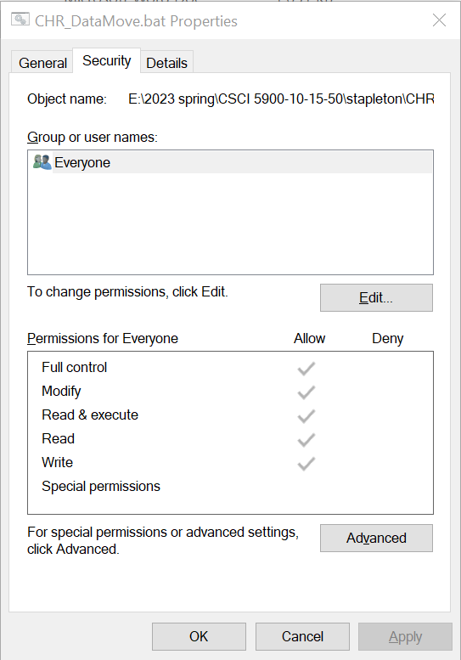

If Administrator is not part of the list of group and user names, use Edit > Add to add Administrator to the menu:

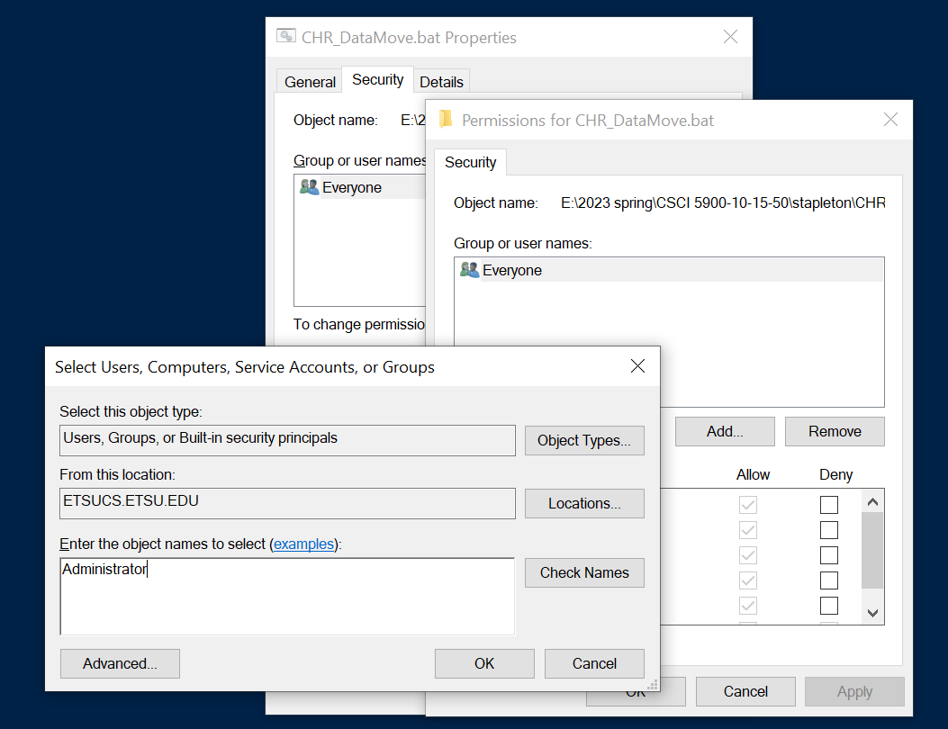

Then use the updated menu to deny execute, write, and modify permission to the Everyone role while adding those permissions to the Administrator role. First, select Administrator and confirm that this role has Read and Execute permissions. Then, select Everyone and deny modify permission; this should also deny other read, execute, and write permissions to non-privileged users:

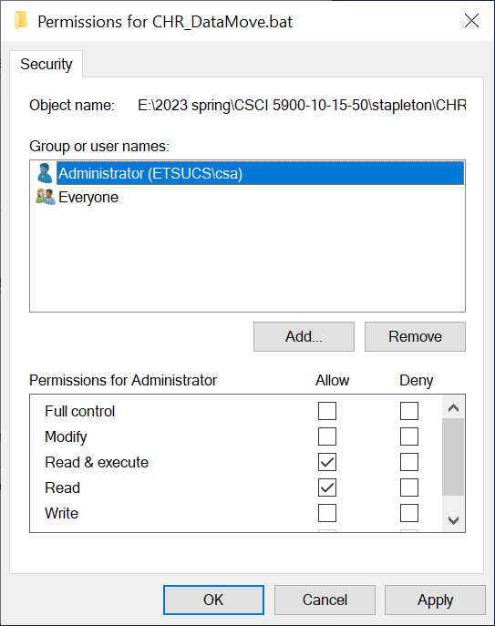 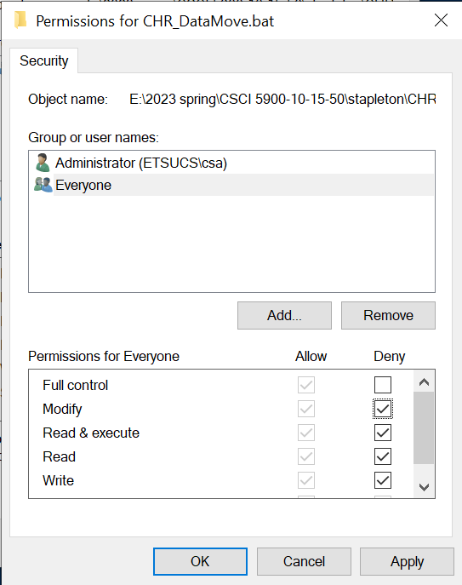

Finish by clicking Apply to apply the permissions, then OK to exit.

## Using CHR_DataMove

If CHR_DataMove has been properly installed and configured, attempting to execute this script should raise an error if the user is not an Administrator.

For administrators, it should be possible to run the script in one of two ways:

* By double-clicking on the icon.
  + This action should attempt to move the current year’s CHR data document from the CHR-DataGrab directory to the CHR-Plot directory.
  + This action will fail with an error message in the event of any of the following issues:
    - The default path to the CHR-DataGrab directory has been misconfigured or the directory has been removed. *This should not happen.*
    - The default path to the CHR-Plot directory has been misconfigured. *This should not happen.*
    - The prefix and suffix variables that are used to infer data file names from the current year have been misconfigured. *This should not happen.*
    - CHR data for the current calendar year has not been downloaded.
* 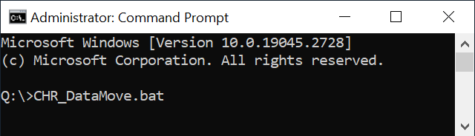By running CHR_DataMove.bat from an Administrator CMD prompt (right).
  + The CMD prompt can be invoked by
    - Entering *CMD /v:on* in the “Type here to search” bar
    - Selecting Run as administrator from the resulting menu:

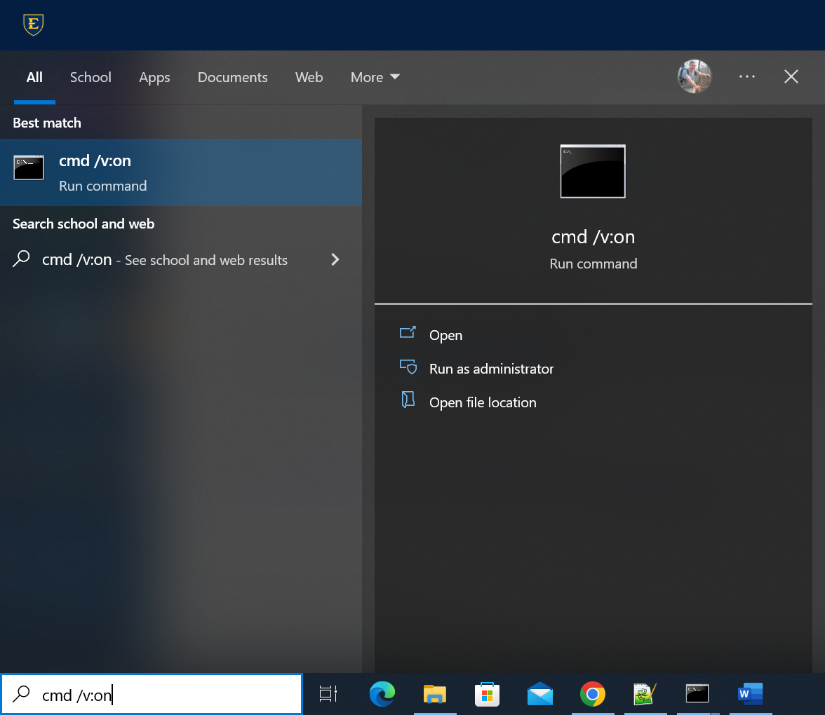

* + In this mode, CHR-DataMove can be run with one, two, or three parameters:
    - With one parameter: year to access
      * The source (CHR-DataGrab) directory and the target (CHR-Plot) directory will default to directories specified at installation.
    - With two parameters: year to access, source (CHR-DataGrab) directory
      * The target (CHR-Plot) directory will default to the directory specified at installation.
    - With three parameters: year to access, source directory, target (CHR-Plot) directory

The principle use of the command-line version of CHR_DataMove should be to load years other than the current into the CHR-Plot directory. Ideally, this data should be loaded exactly once.

If CHR_DataMove is used to load a file that is already in the CHR-Plot directory, CHR_DataMove will prompt for permission to overwrite the existing file. Entering any string other than y or Y will abort the move.

# CHR Web Application – What Was Not Finished

The vision for what CHR-Plot was meant to be and do has not been fully realized, due to a lack of time to implement a number of desirable features. Ideally, this application will be upgraded at some point to support the following features:

* ***Anomaly detection.*** CHR-Plot should be updated to warn users of possible outliers and plots involving health indicators for which counties have either no data or suspect data. The UI’s lower right-hand corner can be used for anomaly reporting.
* ***CHR data notification and downloading.*** CHR-Plot, when run, could check for CHR data that has yet to be downloaded and notify its users when new data is available from UW-PHI. Alternatively, CHR-Plot or a timer program could invoke CHR-DataGrab in the background on detecting newly available data.
* ***Filtering counties by state.*** Rather than requiring users to scan through all 3000+ U.S. counties and independent cities to select a desired set of plot points, a filter could be added to restrict the “choose counties” menu to counties within one or more user-specified states.
* ***Filtering plot data by region.*** Rather than generating percentile lines that reflect all 3,000+ U.S. counties and independent cities, a filter could be added to restrict the points on the percentile chart baseline to a limited number of counties: e.g., plot only against counties east of the Mississippi.
* ***Time series data.*** This feature would show how a county’s status changes over a period of years. One difficulty with this feature would be indicating how UW-PHI data has changed over time, in terms of the sources from which UW-PHI gathers data as well as the overall set of U.S. counties. This set of counties has changed just since 2010, when data was first collected, due to the remaining of counties, the fissioning of counties to create new counties, and the absorption of formerly independent cities (in Virginia) to surrounding counties.
* ***Scatter plot.*** Support for a second, two-indicator scatter plot should be added to CHR-Plot/

In addition, the applications’ code base should be reviewed to improve its clarity and to remove code that was written and later abandoned.

A final vision for this application that was not completed was the replacement of its C# implementation with a Python-based implementation that provided its users with access to standard Python data analytics libraries, like scipy, numpy, matplotlib, and pandas. To extend the current, C# implementation, a new custom interface would need to be created for each additional plot type, using the admittedly powerful but esoteric D3 plot library. Putting a Python front end on CHR data would make the data eminently amenable to a much broader range of visualization strategies for anyone versed in contemporary technologies for data analysis.

1. Special thanks are due to the current implementation’s two primary contributors, ETSU alumni Josh Trimm and Randall Stapleton.
2. https://www.countyhealthrankings.org/?&utm_source=google&utm_medium=paidsocial&utm_campaign=rankings2023